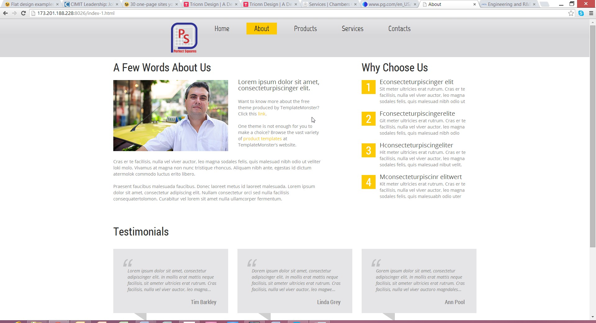

Group Picture of the Owners

Talk about the company's goal, mission statement, how the company came about, why they got together, how they shared a common goal.

**Include a picture of each person, a little background how they got where they are, their education, goals, expertise, passion, responsibility within the company and etc.**

Insert: Founded in, Partners, Projects Funded, Active Projects, # of Patents, Licenses, Future

Brian

Sameer

Hoa

Change to "Leadership"

Change Title to Key Facts